Quiz 2.5] The probability that a call is a voice call is. The probability of a data call is. Voice calls cost 25 cents each and data calls cost 40 cents each. Let C equal the cost of one telephone call

Find.

1. PMF.
2. The expected value.

1.



2.



**2.6 Functions of a Random Variable**

***Derived random variable* ** is a mathematical function  of a sample value  of another random variable





to describe the relationship of two random variable.

***Sample value of*** 

Perform an experiment and observe an outcome *s.*

From *s,* find *x,* the corresponding value of *X.*

Observe *y* by calculating 

**Example 2.27**

The random variable  is the number of pages in a facsimile transmission. Based on experience, you have a probability model  for the number of pages in each fax you send. The phone company offers you a new charging plan for faxes: $0.10 for the first page, $0.09 for the second page, etc., down to $0.06 for the fifth page. For all faxes between 6 and 10 pages, the phone company will charge $0.50 per fax. (It will not accept faxes longer than ten pages.) Find a function for the charge in cents for sending one fax.



Case I.



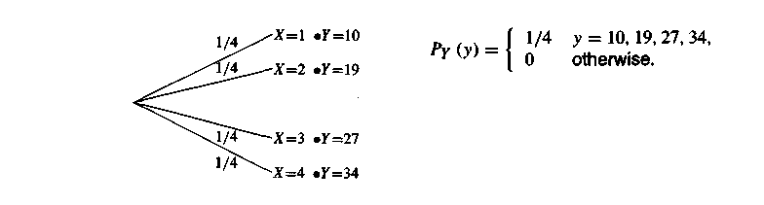

What is  and?

Case I







Case II







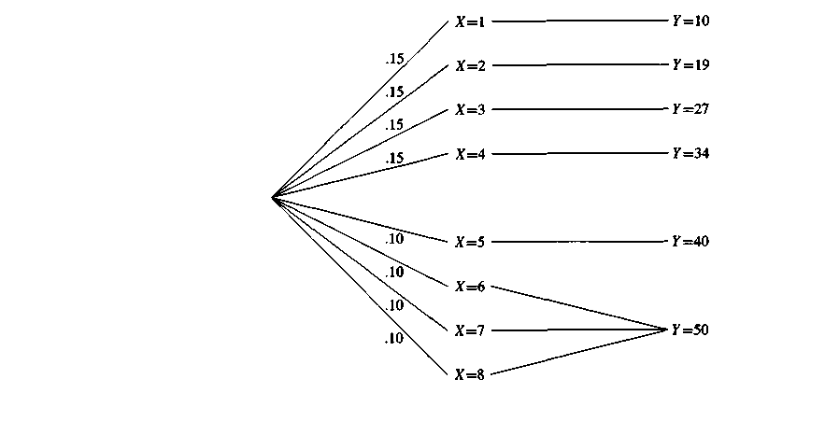





Theorem 2.11

For any random variable 



Proof:



*Note* : 

Theorem 2.12



**2.8 Variance and Standard Deviation**

Variance of random variable  describes the difference between  and its expected value.





Standard deviation



Moments

The  moments is 

The  central moments is 



Ex] 2.34

What is the variance of?

Random variable  has PMF and 



or 



so, 

Ex 2.35] It is defined that .

What is  and ?



Ex 2.36] PMF is given as below



What is the variance of ?



Quiz 2.8] In an experiment to monitor two calls, the PMF of N the number of voice calls, is



i. ?

ii. ?

iii. 

iv. 

i. 

ii. 

iii. 

iv. 